Earth4B
lime cycle
10 questions · easy 3 / medium 4 / difficult 3 · Set 4
Easy (a) · 3 questions
1. Earth4Ba · Lime cycle · Easy Notes p.12 Answer B
Which equation represents the thermal decomposition of calcium carbonate?
A. CaO + H2O → Ca(OH)2
B. CaCO3 → CaO + CO2 ✓
C. Ca(OH)2 + CO2 → CaCO3 + H2O
D. CaCO3 + 2HCl → CaCl2 + CO2 + H2O
2. Earth4Ba · Lime cycle · Easy Notes p.12 Answer A
The reaction that makes limewater turn milky is
A. Ca(OH)2(aq) + CO2(g) → CaCO3(s) + H2O(l) ✓
B. CaCO3(s) → CaO(s) + CO2(g)
C. CaO(s) + H2O(l) → Ca(OH)2(s)
D. CaCO3(s) + H2O(l) + CO2(g) → Ca(HCO3)2(aq)
3. Earth4Ba · Lime cycle · Easy Notes p.11 Answer C
Limestone can be used to
A. make margarine
B. make ammonia as rocket fuel
C. neutralise acidic soil ✓
D. sterilise swimming pools
Medium (b) · 4 questions
4. Earth4Bb · Lime cycle · Medium Notes p.12 Answer B
The diagram shows a kiln used to heat limestone.
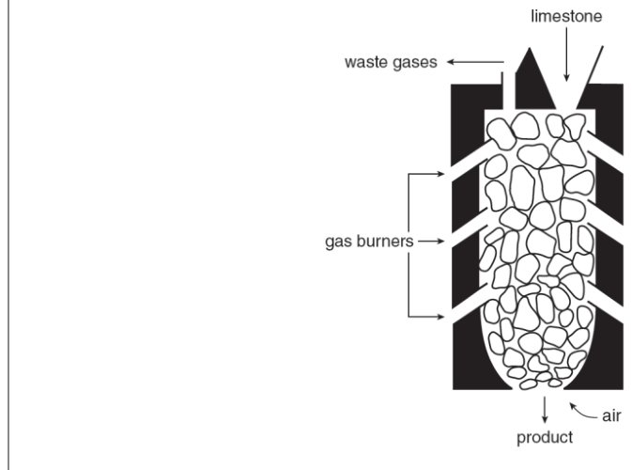
Which statement about the process in the kiln is correct?
A. Slaked lime is the main solid product and CO is the waste gas.
B. Thermal decomposition gives quicklime; the waste gas turns limewater milky. ✓
C. The solid product is limewater and no gas is produced.
D. Marble cannot undergo this change because it is not CaCO3.
5. Earth4Bb · Lime cycle · Medium Notes p.12 Answer C
Which statements about adding dilute hydrochloric acid to limestone are correct?
(1) A colourless gas is evolved.
(2) The limestone dissolves.
(3) Slaked lime is the solid product.
A. (1) and (3) only
B. (2) and (3) only
C. (1) and (2) only ✓
D. (1), (2) and (3)
6. Earth4Bb · Lime cycle · Medium Notes p.12 Answer A
What is the correct laboratory sequence to obtain limewater from quicklime?
A. add excess water → filter → collect filtrate ✓
B. strong heat → collect gas only
C. add dilute HCl → filter
D. pass CO2 until milky → stop
7. Earth4Bb · Lime cycle · Medium Notes p.11 Answer D
Which equation shows formation of carbonic acid in rainwater?
A. CaCO3 + H2CO3 → Ca(HCO3)2
B. Ca(OH)2 + CO2 → CaCO3 + H2O
C. CaCO3 → CaO + CO2
D. CO2 + H2O → H2CO3 ✓
Difficult (c) · 3 questions
8. Earth4Bc · Lime cycle · Difficult Notes p.12 Answer B
CO2 is passed into limewater. The mixture first turns milky, then colourless if excess CO2 is used.
Which substances form at the milky stage and the final colourless stage?
 | Milky stage | Colourless stage
A. | Ca(HCO3)2 | CaCO3
B. ✓ | CaCO3 | Ca(HCO3)2
C. | CaO | Ca(OH)2
D. | CaCl2 | CaCO3

9. Earth4Bc · Lime cycle · Difficult Notes p.12 Answer C
To test whether a solid contains carbonate,
A. heat it alone and smell the gas
B. add water and look for a white suspension only
C. add dilute hydrochloric acid and pass any gas into limewater ✓
D. add silver nitrate solution after nitric acid
10. Earth4Bc · Lime cycle · Difficult Notes p.12 Answer A
Which statements are correct?
(1) Quicklime is produced by strong heating of calcium carbonate.
(2) Slaked lime is produced by adding water to quicklime.
(3) Passing CO2 into limewater regenerates calcium carbonate.
A. (1), (2) and (3) ✓
B. (1) and (2) only
C. (1) and (3) only
D. (2) and (3) only

Earth4B Answer key
New number → difficulty → answer → notes location
No. | Diff | Answer | Source
1 | easy (a) | B | topic-01-planet-earth.pdf p.12 (chemical equation 1)
2 | easy (a) | A | topic-01-planet-earth.pdf p.12 (reaction 4)
3 | easy (a) | C | topic-01-planet-earth.pdf p.11 (uses of limestone)
4 | medium (b) | B | topic-01-planet-earth.pdf p.12 (kiln / thermal decomposition)
5 | medium (b) | C | topic-01-planet-earth.pdf p.12 (reaction 6 / acid)
6 | medium (b) | A | topic-01-planet-earth.pdf p.12 (forming limewater)
7 | medium (b) | D | topic-01-planet-earth.pdf p.11 (carbonic acid equations)
8 | difficult (c) | B | topic-01-planet-earth.pdf p.12 (reactions 4 and 5)
9 | difficult (c) | C | topic-01-planet-earth.pdf p.12 (test for carbonate apparatus)
10 | difficult (c) | A | topic-01-planet-earth.pdf p.12 (full lime cycle links)

